**Unit-II**

**Analysis of HVDC Converters**

The basic configuration of a 3-phase converter (both LCC and VSC) is a bridge converter (and also called Graetz bridge) which can be fed transformer windings’s connected in star (or) delta.The converter transformer feeding a graetz bridge serves the objectives of providing :

1. Galvonic separation between Ac and Dc sides
2. Voltage transformation between Ac and Dc networks
3. Adjustment of the applied Ac voltage by On Load Tap Changer (OLTC).

The ratio of the base frequency of the Dc voltage ripple to the fundamental frequency of the ac voltage .

**CHOICE OF CONVERTER CONFIGURATION:**

Graetz bridge is a six pulse converter for which the lowest Dc voltage is sixth(6th).Correspondingly, lowest Ac current harmonic’s are 5th and 7th.To reduce the harmonic content in the Ac current and Dc voltage, it is desirable to use higher pulse number’s.

In general,

Hdc =np, Hac =np±1

Where n is an integer , p is the pulse number.

To reduce harmonic content in Dc voltage and Ac current, we have to use higher pulse number. There are several configurations for a converter of a specified pulse number. Let us consider a ‘p’ pulse converter made up of series and parallel connections of a basic valve (commutation) group of ‘q’ valves (or) switches. If the converter is made up of a matrix of ‘s’ valve group’s in series and ‘r’ valve group’s in parallel as shown in fig.(1).

P =qrs

1,r

1,2

1,1 1

Vd

2,2

2,1

S,r

S,2

S,1

Fig(1):Converter made up of series and parallel connection of communication groups.

**VALVE RATING:**

The valve voltage rating is termed in PIV (Peak Inverse Voltage).The average maximum dc voltage across the converter is given by:

=

=Em

The Peak Inverse Voltage (PIV) across a valve can be obtained as follows:

1. If ‘q’ is even, then the maximum inverse voltage occurs when the valve with a phase displacement of $π$ radian(180 $°$) is conducting and this is given by

1. If ‘q’ is odd, maximum inverse voltage occurs when the valve with a phase shift of $π±\frac{π}{q}$ is conducting. In this case,

The valve utilisation factor is given by

$\frac{PIV}{Vd0}=\frac{2Em}{\frac{sq}{π}EmSin\frac{π}{2q}}$

For q is even,

For q is odd

Table: Valve utilization factor.

|  |  |  |  |  |
| --- | --- | --- | --- | --- |
| S.No | q | R | s | $$\frac{PIV}{Vd0}$$ |
| 1. | 2 | 1 | 3 | 1.047 |
| 2. | 2 | 3 | 1 | 3.142 |
| 3. | 3 | 1 | 2 | 1.047 |
| 4. | 3 | 2 | 1 | 2.094 |
| 5. | 6 | 1 | 1 | 2.094 |

The table shows the valve utilization factor for different 6 pulse converter configurations.The best valve utilization is obtained for configurations 1and 3.

**TRANSFORMER RATING:**

The current rating of the valve is given by Iv = $\frac{Id}{r\sqrt{q}}$

Id is the DC current which is constant

The transformer rating on the valve side (in VoltAmp) is given by

$Stv=p*\frac{Em}{\sqrt{2}}Iv$

$=p*\frac{Vd0π}{sqSin\frac{π}{q}}*\frac{1}{\sqrt{2}}*\frac{Id}{r\sqrt{q}}$

$=\frac{π}{\sqrt{2}}*\frac{p*Vd0*Id}{qrs*\sqrt{q}*Sin\frac{π}{q}}$

$=\frac{π}{\sqrt{2}}*\frac{qrs*Vd0*Id}{qrs*\sqrt{q}*Sin\frac{π}{q}}$

$Stv=\frac{π}{\sqrt{2}}*\frac{Vd0*Id}{\sqrt{q}*Sin\frac{π}{q}}$

The transformer utilization factor $\frac{Stv}{Vd0*Id}$ is only a function of

$$\frac{Stv}{Vd0*Id}=\frac{π}{\sqrt{2q}Sin\frac{π}{q}}$$

The optimum value of q is 3 then we get maximum utilization =1.481.

**TWELVE PULSE CONVERTER:**

In HVDC transmission ,the series conduction of converter groups has been preferred because of the ease of control and protection as well as the requirements of high voltage rating.Thus,a 12 pulse converter is obtained by the series connection of two bridges.The 30 $°$ phase displacement between the two sets of source voltages is achieved by the transformer connections,star/star for feeding one bridge and star/delta for feeding the second bridge.The use of 12 pulse converter is preferrable over 6 pulse converter because of reduced filtering requirements.

**ANALYSIS OF GRAETZ BRIDGE WITHOUT OVERLAP:**

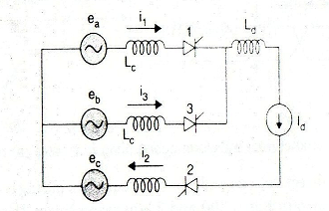

Graetz bridge is connected to three balanced sinusoidal voltage sources on the AC side and constant DC current source on DC side as shown in the above figure.Each of switches S1 to S6 in the graetz bridge are made of series connected thyristor devices.The valve bridge is denoted by the thyristor symbol as shownin fig.

K(cathode)

G

(gate)

A(anode)

Fig: thyristor symbol

A thyristor valve can be viewed as a switch which can be turned ON when the terminal A(anode) is positive with respect to terminal K and a gate (firing) signal is provided at the terminal G.Once the thyristor is switched ON,it can be turned OFF only whwn the current through it goes to zero and there is a minimum commutation margin.Note that thge current can flow only in one direction through the thyristor switch (from anode to cathode) where it is ON. Thus, the switches S1,S4,S6 carry current from the terminal ‘N’.The direct current Id has to flow through atleast one valve in the upper group (S1,S3 and S5) and one valve in the lower group (S2,S4 and S6).Thus ,in a cycle of the applied AC voltage,there are six equal intervals as shown in fig.3.

|  |  |  |  |  |  |  |
| --- | --- | --- | --- | --- | --- | --- |
| Interval | 1 | 2 | 3 | 4 | 5 | 6 |
| Valves conducting | 2,3 | 3,4 | 4,5 | 5,6 | 6,1 | 1,2 |
| Voltage(VPN) | ebc | eba | eca | ecb | eab | eac |

**Table:**DC Bus voltages during each interval.

The expressions for the DC voltage (VPN) and voltage across valve1 for each interval are as shown in below table.

|  |  |  |  |
| --- | --- | --- | --- |
| Interval No. | Conducting valves | DC voltage | Voltage across valve1 |
| 1 | 2,3 | $$\sqrt{2}ELL Sin(wt+60°)$$ | eab= |
| 2 | 3,4 | $$\sqrt{2}ELL Sin wt$$ | eab= |
| 3 | 4,5 | $$\sqrt{2}ELL Sin(wt-60°)$$ | eac= |
| 4 | 5,6 | $$\sqrt{2}ELL Sin(wt-120°)$$ | eac= |
| 5 | 6,1 | $$\sqrt{2}ELL Sin(wt-180°)$$ | 0 |
| 6 | 1,2 | $$\sqrt{2}ELL Sin(wt-240°)$$ | 0 |

**Table:**DC and valve voltages

The waveforms of these voltages for $α=0°,45°,90°,135° and 180°$ are as shown in fig4. The average DC voltage reduces as α is increased from 0 $°$ to 90 $°$.On the other hand ,as α is increased from 90 $°$ to 180 $°$, the average dc voltage increases (in the negative direction) and the ripple content reduces.

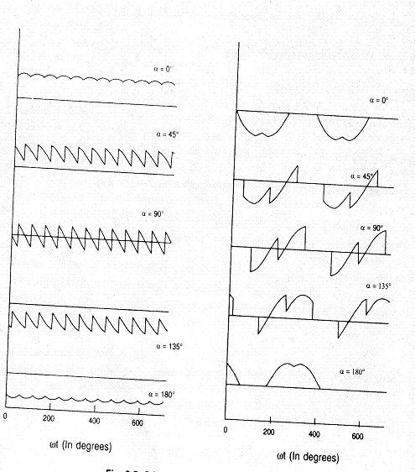

Average dc voltage $Vd=\frac{3}{π}\int_{α}^{α+60°}{\sqrt{2}}ELL Sin \left(wt+60°\right)dwt$

$=\frac{3\sqrt{2}}{π}ELL\int_{α}^{α+60°}{Sin \left(wt+60°\right)dwt}$

$=\frac{3\sqrt{2}}{π}ELL[Cosα-Cos(α+60°)$

$$Vd=Vd0*Cosα$$

**ANALYSIS OF GRAETZ BRIDGE WITH OVERLAP:**

Due to leakage inductance of the converter transformer and the impedance in the supply network ,thge current in the valve cannot change suddenly and thus commutation from one valve to the next cannot be instantaneous.For example,whwn valve 3 is fixed,the current transfer from valve 1 to valve 3 takes a finite period during which both valves are conducting.This is called over lap (commutation) angle ‘u’.

There are 3 modes of the converter.They are:

1. Mode 1 – Two and three valve conduction ($u<60°$)
2. Mode 2 – Three valve conduction ($u=60°$)
3. Mode 3 – Three and four valve conduction ($u>60°$)

Depending upon the delay angle α,the mode 2 may be just a point on the boundary of modes 1 and 3.

1. **ANALYSIS OF TWO AND THREE VALVE CONDUCTION MODE ($u<60°$):**

For the interval considered, the bridge circuit can be reduced to that shown in fig.

For this circuit,

eb-ea

eb-ea

eb-ea

commutating EMF is also the voltage across valve 3 before it starts conducting.Since,

i1=Id-i3

we get,

Solving the above equation taking the limits

Where

At

This gives

**Average direct voltage:**

The average direct voltage can be obtained as

From equ. 6 and 7 we get

1. **ANALYSIS OF THREE AND FOUR VALVE CONDUCTION MODE (U>60 $°$):**

When the overlap angle exceeds 60 $°$,the minimum number of valves conducting are three and there are intervals when four valves are conducting.This is because when a commutation process is started,the previous commutation process is not yet completed.

The Average dc voltage is obtained as

$Vd=\frac{3}{π}\int_{α+u-60°}^{α+60°}{-\frac{3}{2}ec dwt}$

Where $ec=-EMCoswt$ and $EM=\sqrt{\frac{2}{3}}ELL$

$Vd=\frac{3 }{π}*\frac{3}{2}\int_{α+u-60°}^{α+60°}{-\sqrt{\frac{2}{3}}ELL Coswt dwt}$

$=\frac{3 }{π}*\frac{3}{2}*-\sqrt{\frac{2}{3}}ELL\int_{α+u-60°}^{α+60°}{ Coswt dwt}$

$=\frac{\sqrt{3}}{2}Vd0[Sin\left(α+60°\right)-Sin\left(α+u-60°\right)]$

$=\frac{\sqrt{3}}{2}Vd0[Cos\left(α-30°\right)+Cos\left(α+u+30°\right)]$

$Vd=Vd0[\sqrt{3}Cos\left(α-30°\right)-\frac{3}{2}\frac{Id}{Is}$]

Where $Id=\frac{Is}{2}[Cos\left(α-30°\right)-\frac{3}{2}*\frac{Id}{Is}]$

1. **ANALYSIS OF 3 VALVE CONDUCTION MODE (U=60 $°$):**

For mode 2,u=60 $°$.For u=constant , the characteristics are elliptical and the equation is given by

$${\left(\frac{\overline{Vd}}{Cos\frac{u}{2}}\right)}^{2}+{\left(\frac{\overline{Id}}{Sin\frac{u}{2}}\right)}^{2}=1$$

Where $\overline{Id}=\frac{Id}{2*Is}$

**RECTIFIER:**

The rectifier in general has three modes:

1. First mode : Two and three valve conduction mode $(u<60°)$
2. Second mode: Three valve conduction mode $0≤α≤30°;(u=60°)$
3. Third mode:Three and four valve conduction mode $α>30°(60°<u≤120°)$

For modes (1) and (3) we have

For mode (2), $u=60°$.For u=constant,and the equation is given by

From (1) and (2) equations , we get

An inverter can operate in either Mode1 ($u<60°$, two and three valve conduction mode) (or) Mode2($u>60°$,three and four valve conduction mode)

In the inverter operation , it is necessary to maintain a certain minimum margin angle $ξ.$ This results in 3 sub-modes of the first mode.

**MODE 1:**

**1(a.) $β<60°,$**

The commutation margin angle ($ξ$) is equal to the extinction angle($γ$) only for values of $β<60°.$

The characteristics are linear defined by

**1(b.)**

When the inverter operating in mode 1(b) then the extinction angle is varied and u is constant, $γ$ is varied.

$u=60°- ξ$ = constant.

**1(c.) $90°<β<90°+ξ$**

When the inverter operates in mode 1(c.) then the extinction angle is constant and u is varied.

The characteristics in this case are linear defined by

**MODE 2:**

For $u<60°$ corresponding to $β>90°+γ$

The characteristics are again linear but with a different slope and is defined by

**CHARACTERISTICS OF CONVERTER:**

The voltage and current characteristics are linear in case of rectifier.

Equ’s (2) follows the following equations in rectifier

$\overline{Vd}=\frac{1}{2}\left[Cosα+Cos(α+u)\right]$

$\overline{Id}=\frac{1}{2}\left[Cosα-Cos(α+u)\right]$

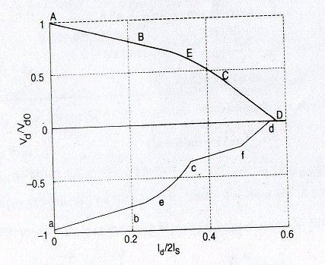

The boundary for the rectifier operation is shown in below fig.The coordinates of points A,B,C,D and E on the boundary are given in below table 1.The point E corresponds to the maximum power output of the converter.The inverter characteristics are similar to the rectifier characteristics .The operation of inverter requires a minimum commutation angle during which the voltage across the valve is negative.Hence the operating region of an invereter is different from that for a rectifier.

The boundary of the inverter operation for a valve of $ξ=15°$ is shown in below fig.The coordinates of points a,b,c,d,e and f on the boundary are given in below table 2. The maximum power supplied by the inverter occurs at $γ=22.5° and u=45°$ (point e).In the normal operation of the converter $\overline{Id}$ is in the range of 0.08 to 0.1.Hence,only the first linear portion of the characteristics is of importance in the converter control.

**Table:**Boundary of Rectifier characteristics

|  |  |  |  |  |
| --- | --- | --- | --- | --- |
| point | $$α$$ | $$u$$ | $$\overline{Id}$$ | $$\overline{Vd}$$ |
| A | 0 | 0 | 0 | 1.0 |
| B | $$0$$ | $$60°$$ | 0.25 | 0.75 |
| C | $$30°$$ | $$60°$$ | $$\frac{\sqrt{3}}{4}$$ | $$\frac{\sqrt{3}}{4}$$ |
| D | $$30°$$ | $$120°$$ | $$\frac{1}{\sqrt{3}}$$ | 0 |
| E | $$15°$$ | $$60°$$ | $$\frac{1}{2\sqrt{2}}$$ | $$\frac{\sqrt{3}}{2\sqrt{2}}$$ |

**Table:**Boundary of Inverter characteristics

|  |  |  |  |  |
| --- | --- | --- | --- | --- |
| point | $$γ$$ | $$u$$ | $$\overline{Id}$$ | $$\overline{Vd}$$ |
| a | $$15°$$ | $$0$$ | 0 | -0.966 |
| b | $$15°$$ | $$45°$$ | 0.233 | -0.733 |
| c | $$45°$$ | $$45°$$ | 0.354 | -0.354 |
| f | $$45°$$ | $$60°$$ | 0.483 | -0.224 |
| d | $$45°$$ | $$90°$$ | 0.558 | 0 |
| e | $$22.5°$$ | $$45°$$ | 0.271 | -0.654 |